BDA Practical No-1
Decision Tree
Introduction
A Decision Tree is a supervised machine learning algorithm used for classification and regression tasks. It models decision-making by representing possible outcomes in a tree-like structure. Each decision is made by applying simple rules learned from the dataset.
Concept of Decision Tree
The concept of a decision tree is based on dividing a complex problem into smaller and simpler decision steps. Each step checks the value of an attribute and follows a branch based on the result. This continues until a final decision is reached.
Structure of Decision Tree
A decision tree consists of a root node, internal decision nodes, branches, and leaf nodes. The root node represents the complete dataset. Decision nodes represent conditions on attributes. Branches show the outcomes of decisions, and leaf nodes represent the final class label or predicted value.
Working Principle
The decision tree works by selecting the best attribute from the dataset and splitting the data based on that attribute. The same process is applied recursively to each subset. This process is called recursive partitioning. The splitting stops when all records in a node belong to the same class or no useful attributes remain.
Attribute Selection Criteria
Choosing the correct attribute for splitting is important for building an accurate decision tree. Entropy measures the impurity of the dataset. Information Gain measures the reduction in entropy after splitting. The Gini Index measures the probability of misclassification. The attribute that provides the best split is selected.

Splitting Process
The splitting process divides the dataset into smaller subsets based on attribute values. Each split aims to increase data purity and improve classification accuracy.
Stopping Conditions
Tree construction stops when all data in a node belongs to a single class, when no attributes are left for splitting, or when a predefined tree depth is reached to avoid overfitting.
Pruning Technique
Pruning is used to remove unnecessary branches from the decision tree. It helps reduce complexity and improves the performance of the model on unseen data. Pruning can be done before or after the tree is built.
Types of Decision Trees
Decision trees are classified into classification trees and regression trees. Classification trees produce categorical outputs, while regression trees produce continuous numerical outputs.
Advantages of Decision Tree
Decision trees are easy to understand and interpret. They handle both numerical and categorical data and do not require data normalization. They provide a visual representation of decision rules.
Limitations of Decision Tree
Decision trees can overfit the training data and are sensitive to noise. A small change in data can lead to a completely different tree structure.
Applications of Decision Tree
Decision trees are widely used in medical diagnosis, banking systems, loan approval, customer analysis, fraud detection, and decision support systems.
Conclusion
Decision Trees are powerful and simple machine learning models that use logical rules to make decisions. Due to their interpretability and ease of use, they are commonly applied in real-world problem-solving.
Code:
import pandas as pd
from sklearn.tree import DecisionTreeClassifier
from sklearn.model_selection import train_test_split
from sklearn import metrics
df=pd.read_csv("/diabetes.csv")
#loading data
col_names= ['pregnant','glucose', 'bp', 'skin', 'insulin', 'bmi', 'pedigree', 'age', 'label']
pima = pd.read_csv("/diabetes.csv", header=None, names=col_names)
pima.head()
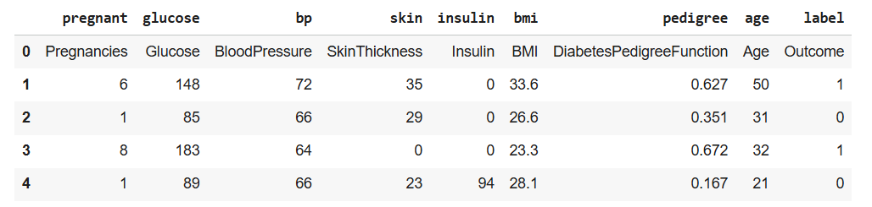
#split dataset in features and target variable
feature_cols = ['pregnant', 'insulin', 'bmi', 'age','glucose','bp','pedigree']
X=pima[feature_cols]
Y=pima.label
X_train, X_test, y_train, y_test = train_test_split(X, Y, test_size=0.3, random_state=1)

pima_cleaned = pima.iloc[1:].copy()
for col in pima_cleaned.columns:
pima_cleaned[col] = pd.to_numeric(pima_cleaned[col], errors='coerce')
pima_cleaned = pima_cleaned.dropna() # Drop rows that couldn't be converted, if any
# Re-split the dataset using the cleaned pima data
X = pima_cleaned[feature_cols]
Y = pima_cleaned.label

X_train, X_test, y_train, y_test = train_test_split(X, Y, test_size=0.3, random_state=1)

clf = DecisionTreeClassifier()
clf = clf.fit(X_train,y_train)
y_pred = clf.predict(X_test)
print("accuracy: ", metrics.accuracy_score(y_test, y_pred))
print("recall: ", metrics.recall_score(y_test, y_pred))
print("precision: ", metrics.precision_score(y_test, y_pred))
print("AUC Score: ", metrics.roc_auc_score(y_test, y_pred))
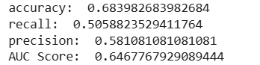
!pip install graphviz
!pip install pydotplus
from sklearn.tree import export_graphviz
from io import StringIO
from IPython.display import Image
import pydotplus
dot_data=StringIO()
export_graphviz(clf, out_file=dot_data, filled=True, rounded=True, special_characters=True, feature_names=feature_cols, class_names=['0','1'])
graph=pydotplus.graph_from_dot_data(dot_data.getvalue())
graph.write_png('diabetes.png')
Image(graph.create_png())

Output:
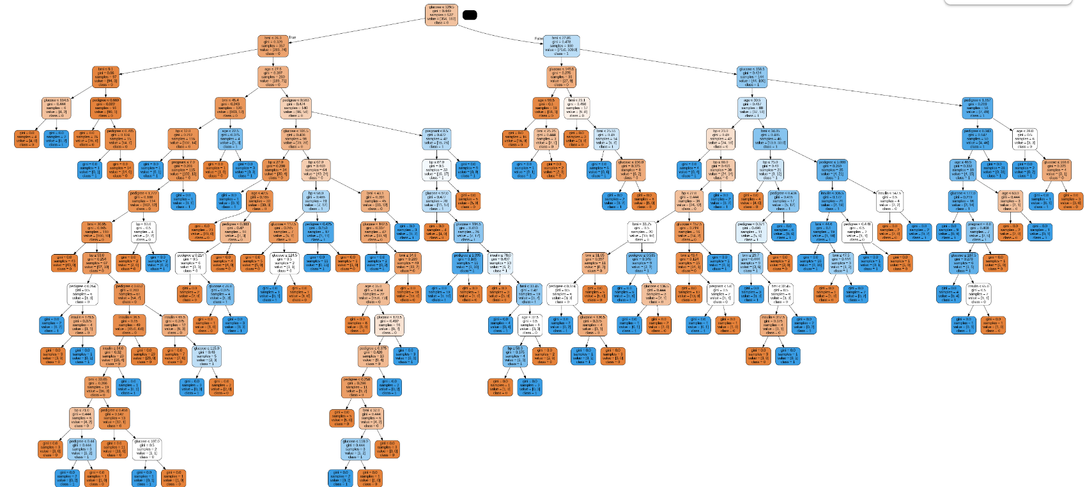

BDA Practical No-2
Linear Regression
Introduction
Linear Regression is a supervised machine learning algorithm used to model the relationship between a dependent variable and one or more independent variables. It is mainly used for predicting continuous values based on given input data.
Concept of Linear Regression
The concept of linear regression is based on fitting a straight line that best represents the relationship between variables. The model assumes that the dependent variable changes linearly with respect to the independent variable.
Linear Regression Model
In linear regression, the relationship between variables is represented using a linear equation. The equation of a simple linear regression model is
y = mx + c,
where y is the dependent variable, x is the independent variable, m is the slope of the line, and c is the intercept.
Working Principle
Linear regression works by finding the best values for the slope and intercept such that the error between the predicted values and actual values is minimized. The most common method used to achieve this is the least squares method.
Least Squares Method
The least squares method minimizes the sum of the squares of the differences between the actual values and the predicted values. This helps in obtaining the best-fitting straight line for the given data.
Types of Linear Regression
Linear regression is classified into simple linear regression, where there is only one independent variable, and multiple linear regression, where two or more independent variables are used to predict the dependent variable.
Assumptions of Linear Regression
Linear regression assumes a linear relationship between variables, independence of observations, constant variance of errors, and normally distributed errors.
Advantages of Linear Regression
Linear regression is easy to understand and implement. It requires less computational power and works well when there is a clear linear relationship between variables.
Limitations of Linear Regression
Linear regression is sensitive to outliers and performs poorly when the relationship between variables is non-linear. It also depends on certain assumptions which may not always hold true.
Applications of Linear Regression
Linear regression is widely used in sales forecasting, price prediction, trend analysis, risk assessment, and economic analysis.
Conclusion
Linear Regression is a fundamental and widely used algorithm for predictive analysis. Due to its simplicity and effectiveness, it is often used as a baseline model in machine learning tasks.

Code:
#import liabraries
import pandas as pd
import numpy as np
import matplotlib.pyplot as plt
import seaborn as sns
from sklearn.model_selection import train_test_split
from pandas.core.common import random_state
from sklearn.linear_model import LinearRegression
from sklearn.metrics import accuracy_score, confusion_matrix, classification_report

df = pd.read_csv('/Salary_Data.csv')
print(df.head())
print(df.describe())
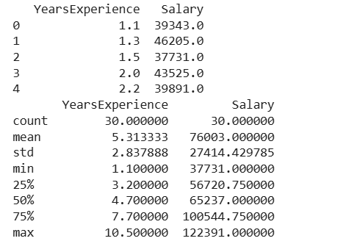
plt.scatter(df['YearsExperience'],df['Salary'],color='lightcoral')
plt.title('Salary vs Experience')
plt.xlabel('Year of Experience')
plt.ylabel('Salary')
plt.box(True)
plt.show()
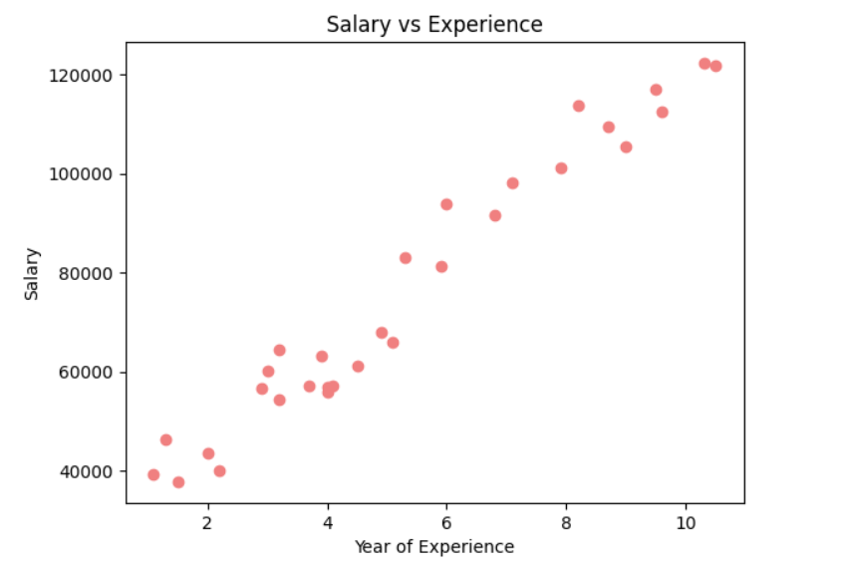
x = df.iloc[:, 0] # YearsExperience
y = df.iloc[:, 1] # Salary

x_train,x_test,y_train,y_test =train_test_split(x,y,test_size=0.2, random_state= 0)
regressor= LinearRegression()
regressor.fit(x_train.values.reshape(-1, 1), y_train)

y_pred_test = regressor.predict(x_test.values.reshape(-1, 1))
y_pred_train = regressor.predict(x_train.values.reshape(-1, 1))

plt.scatter(x_train, y_train, color = 'lightcoral')
plt.plot(x_train, y_pred_train, color = 'firebrick')
plt.title('Salary vs Experience(Training Set)')
plt.xlabel('Years of Experience')
plt.ylabel('Salary')
plt.legend(['X_test/Pred(y_test)','X_train/y_train'], title = 'Sal/Exp', loc = 'best', facecolor = 'lightcoral')
plt.box(False)
plt.show()

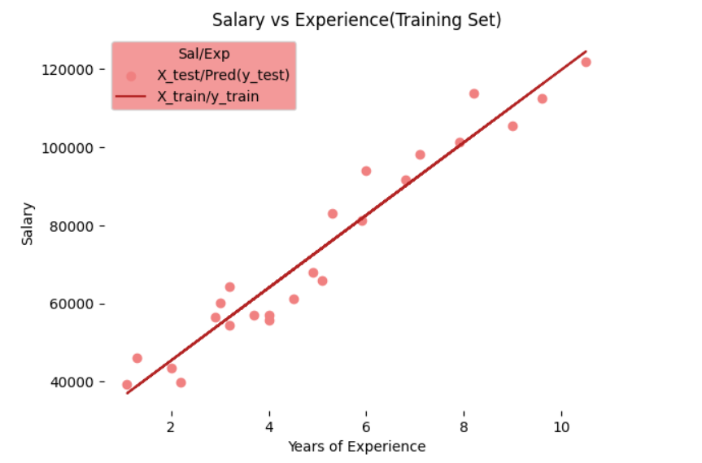
plt.scatter(x_test, y_test, color = 'lightcoral')
plt.plot(x_train, y_pred_train, color = 'firebrick')
plt.title('Salary vs Experience(Training Set)')
plt.xlabel('Years of Experience')
plt.ylabel('Salary')
plt.legend(['X_test/Pred(y_test)','X_test/y_test'], title = 'Sal/Exp', loc = 'best', facecolor = 'lightcoral')
plt.box(False)
plt.show()

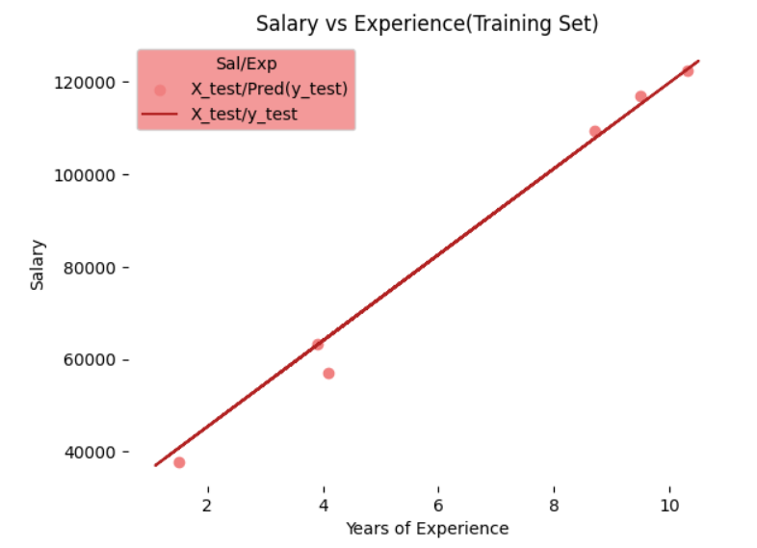
print(f'Coefficent: {regressor.coef_}')
print(f'Intercept: {regressor.intercept_}')
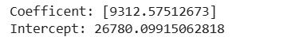

#what is the salary of person if years of person if year of experience = 6.7year
y = regressor.coef_*6.7 + regressor.intercept_
print(y)

years = np.array([6.7])
s = regressor.predict(years.reshape(-1 ,1))
print(s)
#

#build linear regression model predict house price depending on 2 colums number of storag and area
df = pd.read_csv('/content/Housing.csv')
print(df.head())
print(df.describe())
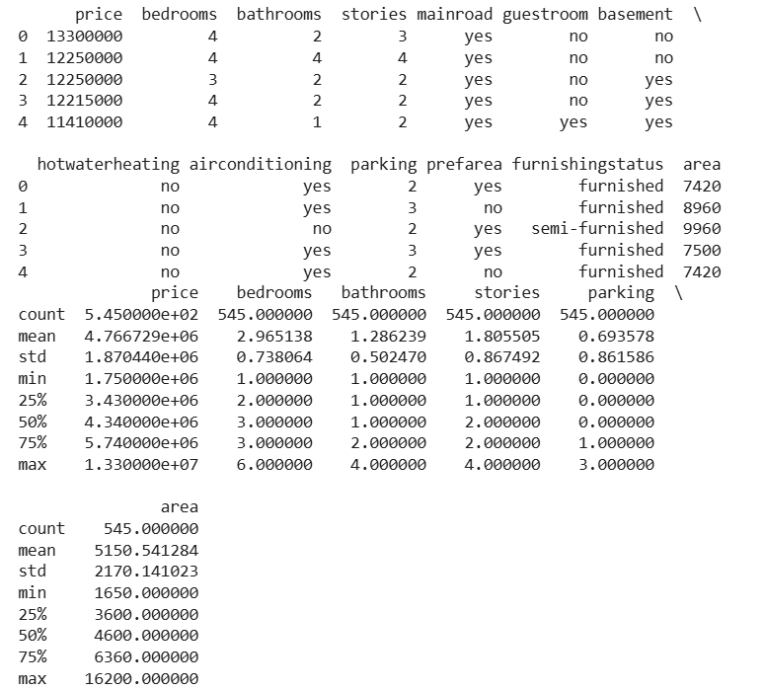

plt.scatter(df['price'],df['area'],color='lightcoral')
plt.title('price vs Area')
plt.xlabel('Area')
plt.ylabel('House price')
plt.box(True)
plt.show()
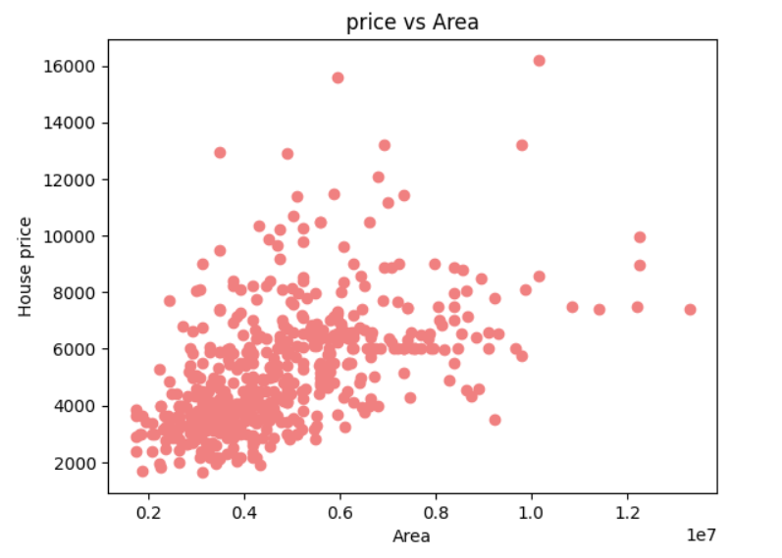
plt.scatter(df['price'],df['stories'],color='black')
plt.title('price vs stories')
plt.xlabel('stories')
plt.ylabel('House price')
plt.box(True)
plt.show()
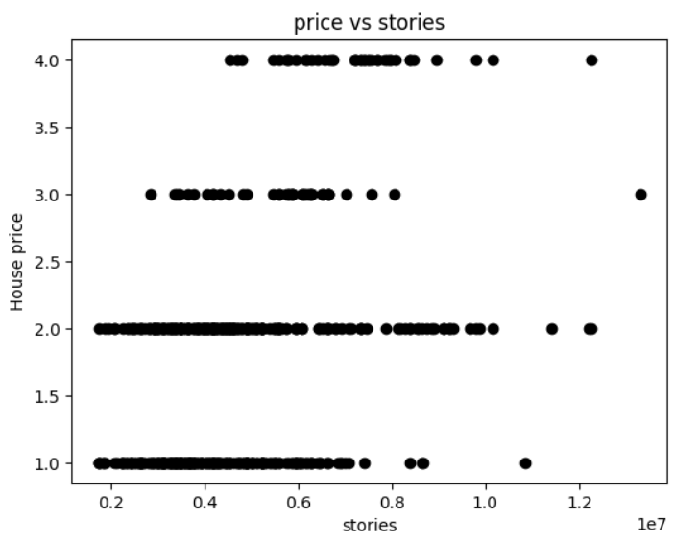
plt.scatter(df['price'],df['area'],color='red')
plt.scatter(df['price'],df['stories'],color='blue')
plt.title('price vs Area and storage ')
plt.xlabel('Area & storage ')
plt.ylabel('House price')
plt.box(True)
plt.show()
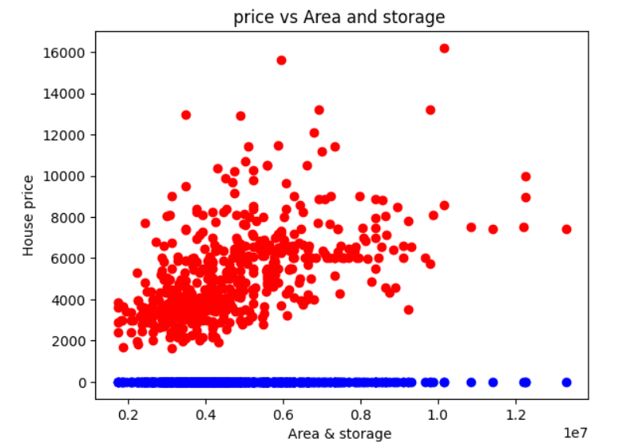
x = df.iloc[:, 0] # YearsExperience
y = df.iloc[:, 1] # Salary

# Define x and y for the Housing dataset based on 'stories' and 'area'
x = df[['stories', 'area']] # Features
y = df['price'] # Target variable

x_train,x_test,y_train,y_test =train_test_split(x,y,test_size=0.2, random_state= 0)
regressor= LinearRegression()
regressor.fit(x_train, y_train)

y_pred_test = regressor.predict(x_test)
y_pred_train = regressor.predict(x_train)

BDA Practical No-3
Logistic Regression
Introduction
Logistic Regression is a supervised machine learning algorithm mainly used for classification problems. It is used when the output variable is categorical, such as Yes/No, True/False, or Pass/Fail. Despite its name, Logistic Regression is a classification technique, not a regression technique.
Concept of Logistic Regression
The concept of Logistic Regression is based on predicting the probability that a given input belongs to a particular class. Instead of predicting continuous values, it predicts probabilities which are then converted into class labels.
Logistic Regression Model
Logistic Regression uses a linear combination of input features and passes the result through a sigmoid function. The sigmoid function converts the output into a value between 0 and 1, representing probability.
Sigmoid Function
The sigmoid function is used to map any real-valued number into a range between 0 and 1. This helps in deciding the class of the output based on a threshold value, usually 0.5.
Working Principle
The working of Logistic Regression starts by calculating a weighted sum of input features. This value is passed through the sigmoid function to obtain the probability of the output belonging to a particular class. Based on this probability, the final class label is assigned.
Types of Logistic Regression
Logistic Regression is classified into binary logistic regression, where the output has two classes, and multinomial logistic regression, where the output has more than two classes.
Cost Function
Logistic Regression uses a cost function called log loss or binary cross-entropy. This cost function measures the difference between the predicted probability and the actual class label.
Model Training
During training, the model adjusts its weights to minimize the cost function. Optimization techniques such as gradient descent are used to find the best parameter values.
Advantages of Logistic Regression
Logistic Regression is simple to understand and implement. It is computationally efficient and works well for linearly separable data. It also provides probabilistic outputs.
Limitations of Logistic Regression
Logistic Regression performs poorly when the relationship between variables is non-linear. It is sensitive to outliers and assumes independence among input features.
Applications
Logistic Regression is widely used in spam email detection, disease diagnosis, credit risk analysis, customer churn prediction, and sentiment analysis.
Conclusion
Logistic Regression is a powerful and widely used classification algorithm. Its simplicity, efficiency, and interpretability make it a popular choice for many real-world classification problems.
Code:
import pandas as pd
import numpy as np
import matplotlib.pyplot as plt
import seaborn as sns
from sklearn.datasets import load_diabetes
from sklearn.model_selection import train_test_split
from sklearn.preprocessing import StandardScaler
from pandas.core.common import random_state
from sklearn.linear_model import LogisticRegression
from sklearn.metrics import accuracy_score, confusion_matrix, classification_report, roc_curve, auc,
precision_score, recall_score

diabetes = load_diabetes()
X, y = diabetes.data, diabetes.target

y_binary = (y>np.median(y)).astype(int)

X_train, X_test, y_train, y_test = train_test_split(X, y_binary, test_size=0.2, random_state=42)

scaler = StandardScaler()
X_train = scaler.fit_transform(X_train)
X_test = scaler.transform(X_test)

#training the model
LRModel = LogisticRegression()
LRModel.fit(X_train, y_train)

Output:

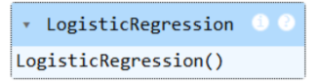

#evaluation of model
y_pred = LRModel.predict(X_test)

#accuracy of LRModel
accuracy_LRModel = accuracy_score(y_test, y_pred)
print("Accuracy of Logistic Regression Model:", accuracy_LRModel * 100)

#precision of LRModel
precision_LRModel = precision_score(y_test, y_pred)
print("Precision of Logistic Regression Model:", precision_LRModel)

#recall of LRModel
recall_LRModel = recall_score(y_test, y_pred)
print("Recall of Logistic Regression Model:", recall_LRModel)

#confusion matrix
print("Confusion Metrix",confusion_matrix(y_test,y_pred))
print("Classification report",classification_report(y_test,y_pred))

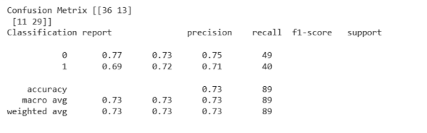
#roc curve
print(roc_curve(y_test, y_pred))

plt.figure(figsize=(8, 6))
sns.scatterplot(x=X_test[:,2], y = X_test[:,7], hue = y_test, palette = {0: 'blue', 1: 'red'},marker = 'o')
plt.xlabel('BMI')
plt.ylabel('Diebetes')
plt.title("Logistic regression boundary\n Accuracy:{:.2f}%".format(accuracy_LRModel*100))
plt.legend(title='Diabetes', loc = 'upper right')
plt.show()

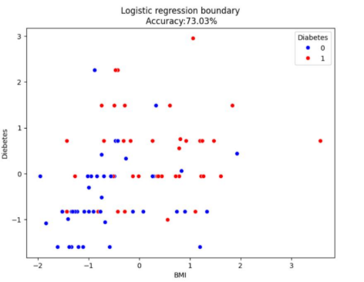
plt.figure(figsize=(8, 6))
sns.scatterplot(x=X_test[:,3], y = X_test[:,7], hue = y_test, palette = {0: 'blue', 1: 'red'},marker = 'o')
plt.xlabel('BP')
plt.ylabel('Colestole S4')
plt.title("Logistic regression boundary\n Accuracy:{:.2f}%".format(accuracy_LRModel*100))
plt.legend(title='Colestole', loc = 'upper right')
plt.show()

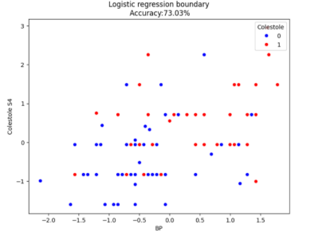
plt.figure(figsize=(8, 6))
sns.scatterplot(x=X_test[:,3], y = X_test[:,9], hue = y_test, palette = {0: 'blue', 1: 'red'},marker = 'o')
plt.xlabel('BP')
plt.ylabel('Blood Sugar')
plt.title("Logistic regression boundary\n Accuracy:{:.2f}%".format(accuracy_LRModel*100))
plt.legend(title='BLood Sugar', loc = 'upper right')
plt.show()

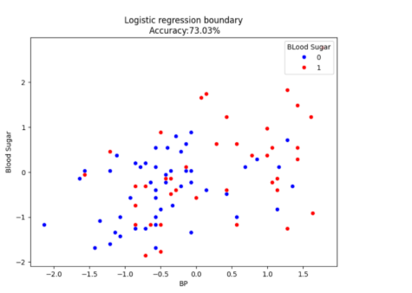
diabetes.feature_names

plt.figure(figsize=(8, 6))
sns.scatterplot(x=X_test[:,0], y = X_test[:,2], hue = y_test, palette = {0: 'blue', 1: 'red'},marker = 'o')
plt.xlabel('Age')
plt.ylabel('BMI')
plt.title("Logistic regression boundary\n Accuracy:{:.2f}%".format(accuracy_LRModel*100))
plt.legend(title='BLood Sugar', loc = 'upper right')
plt.show()

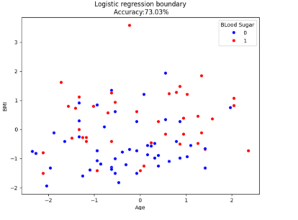
#plotting roc curve
y_prob = LRModel.predict_proba(X_test)[:,1]
fpr, tpr, thresholds = roc_curve(y_test, y_prob)
roc_auc = auc(fpr, tpr)
plt.figure(figsize=(8, 6))
plt.plot(fpr, tpr,color = 'darkorange' , lw = 2, label = f'ROC Curve (AUC = {roc_auc:.2f})')
plt.plot([0,1],[0,1],color = 'navy',lw = 2,linestyle = '--', label = 'Random')
plt.legend(loc = 'lower right')
plt.xlabel('False Positive Rate')
plt.ylabel('True Positive Rate')
plt.title('Receiver Operating Characteristic (ROC) Curve\n Accuracy:{:.2f}%'.format(accuracy_LRModel *
100))
plt.show()
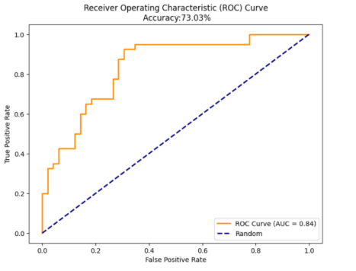

BDA Practical No-4
K-Means Clustering

Introduction
K-Means Clustering is an unsupervised machine learning algorithm used to group data into clusters based on similarity. It is mainly used when the dataset does not have predefined class labels. The algorithm groups data points into K clusters, where each cluster represents similar data points.

Concept of K-Means Clustering
The basic concept of K-Means clustering is to divide the dataset into K groups such that data points within the same cluster are more similar to each other than to those in other clusters. Similarity is usually measured using distance metrics such as Euclidean distance.

Clusters and Centroids
In K-Means clustering, each cluster is represented by a centroid. A centroid is the mean position of all data points belonging to a cluster. The position of centroids changes during the clustering process to improve grouping accuracy.

Working Principle
The working of K-Means clustering begins by selecting K initial centroids randomly. Each data point is assigned to the nearest centroid based on distance. After assignment, new centroids are calculated by finding the mean of all points in each cluster. This process is repeated until the centroids no longer change or the maximum number of iterations is reached.

Distance Measure
Distance measures play an important role in K-Means clustering. Euclidean distance is commonly used to measure the distance between data points and centroids, which helps in determining cluster membership.

Selection of K Value
The value of K represents the number of clusters to be formed. Choosing the correct value of K is important for effective clustering. Techniques such as the Elbow Method are commonly used to select an appropriate K value.

Advantages of K-Means Clustering
K-Means is simple and easy to understand. It is computationally efficient and works well for large datasets. The algorithm is easy to implement and gives fast results.

Limitations of K-Means Clustering
K-Means requires the number of clusters to be specified in advance. It is sensitive to initial centroid selection and outliers. The algorithm performs poorly when clusters are of different sizes or non-spherical shapes.

Applications of K-Means Clustering
K-Means clustering is used in customer segmentation, image compression, market analysis, document clustering, and pattern recognition.

Conclusion
K-Means Clustering is a widely used unsupervised learning algorithm for grouping similar data points. Its simplicity and efficiency make it suitable for many real-world clustering applications.

Code:

import pandas as pd
import numpy as np
import random as rd
import matplotlib.pyplot as plt

data = pd.read_csv('/content/clustering-data.csv')
data.head()
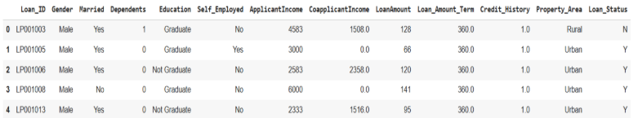

plt.figure(figsize=(8, 6))
X = data[["LoanAmount", "ApplicantIncome"]]
plt.scatter(X['ApplicantIncome'], X['LoanAmount'], color='black')
plt.xlabel('Applicant Income')
plt.ylabel('Loan Amount')
plt.title('Data Visualization')
plt.show()

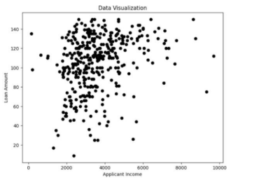

X = data[["LoanAmount", "ApplicantIncome"]]
plt.scatter(X['ApplicantIncome'], X['LoanAmount'], color='black')
plt.xlabel('Applicant Income')
plt.ylabel('Loan Amount')
plt.title('Data Visualization')
k = 3
centroids = (X.sample(n=k))
plt.scatter(centroids['ApplicantIncome'], centroids['LoanAmount'], color='red')
plt.show()
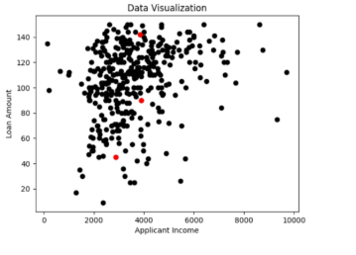
from sklearn.cluster import KMeans

# elbow method for finding cluster k
wcss = []
for i in range(1, 11):
kmeans = KMeans(n_clusters=i, init='k-means++', max_iter=300, n_init=10,random_state=0)
kmeans.fit(X)
wcss.append(kmeans.inertia_)

plt.figure(figsize=(10, 6))
plt.plot(range(1, 11), wcss, marker='o', linestyle='--')
plt.title('Elbow Method')
plt.xlabel('Number of clusters (K)')
plt.ylabel('WCSS')
plt.grid(True)
plt.show()

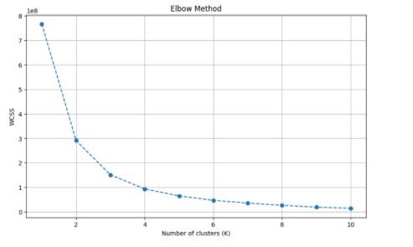
k = 3 # Based on the elbow plot
kmeans = KMeans(n_clusters=k, init='k-means++', max_iter=300, n_init=10, random_state=0)
y_kmeans = kmeans.fit_predict(X)

plt.figure(figsize=(10, 6))
plt.scatter(X['ApplicantIncome'], X['LoanAmount'], c=y_kmeans, cmap='viridis', s=50, alpha=0.7)
plt.scatter(kmeans.cluster_centers_[:, 0], kmeans.cluster_centers_[:, 1], s=200, c='red', marker='X',
label='Centroids')
plt.title('K-Means Clustering (K=3)')
plt.xlabel('Applicant Income')
plt.ylabel('Loan Amount')
plt.legend()
plt.grid(True)
plt.show()

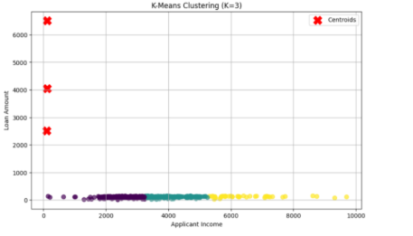
diff = 1
j = 0
while diff != 0:
XD = X.copy()
i = 1
for index1, row_c in Centroids.iterrows():
ED = []
for index2, row_d in XD.iterrows():
d1 = (row_c['ApplicantIncome']-row_d['ApplicantIncome'])**2
d2 = (row_c['LoanAmount']-row_d['LoanAmount'])**2
d = np.sqrt(d1 + d2)
ED.append(d)

X.loc[:,1] = ED
i = i + 1

C = []
for index, row in X.iterrows():
min_dist = row[1]
pos = 1
for i in range(k):
if row[i+1] < min_dist:
min_dist = row[i+1]
pos = i+1
C.append(pos)
X.iloc[:,"Cluster"] = C
Centroids_new = X.groupby(by="Cluster").mean()[['ApplicantIncome', 'LoanAmount']]
if j == 0:
diff = 1
j = j + 1
else:
diff = (Centroids_new['ApplicantIncome'] - Centroids['ApplicantIncome']).sum() +
(Centroids_new['LoanAmount'] - Centroids['LoanAmount']).sum()
print(diff.sum())
Centroids = X.groupby(by="Cluster").mean()[['ApplicantIncome', 'LoanAmount']]

print("Final Cluster Centroids:")
print(kmeans.cluster_centers_)

X_clustered = X.copy()
X_clustered['Cluster'] = y_kmeans
print("\nData with Cluster Assignments:")
print(X_clustered)

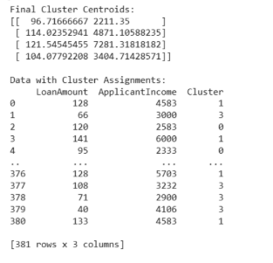
color = ['blue', 'green', 'red', 'cyan']
plt.figure(figsize=(10, 6))
for cluster_label in range(k):
data_cluster = X_clustered[X_clustered['Cluster'] == cluster_label]
plt.scatter(data_cluster['ApplicantIncome'], data_cluster['LoanAmount'], c = color[cluster_label],
label=f'Cluster {cluster_label + 1}')
plt.scatter(kmeans.cluster_centers_[:, 0], kmeans.cluster_centers_[:, 1], s=200, c='black', marker='X',
label='Centroids')
plt.xlabel('Applicant Income')

plt.ylabel('Loan Amount')
plt.title('K-Means Clustering (K=4)')
plt.legend()
plt.grid(True)
plt.show()

BDA Practical No-5
House Price Predection linear Regression

Introduction
House price prediction is an important application of machine learning that helps in estimating the price of a house based on various factors. Linear Regression is commonly used for this purpose because it can model the relationship between house price and influencing features such as area, number of rooms, location, and age of the house.
Problem Description
The objective of this practical is to predict the price of a house using Linear Regression. The house price is treated as the dependent variable, while factors like size of the house, number of bedrooms, location, and other attributes are considered as independent variables.
Dataset Description
The dataset used for house price prediction contains records of houses with different features. Each record includes values such as house area, number of rooms, location-related features, and the corresponding house price. This dataset is used to train and test the Linear Regression model.
Linear Regression Model
Linear Regression establishes a linear relationship between the house price and the input features. The model predicts the house price using a linear equation where the output is calculated as a weighted sum of input features along with a bias term.
Working Principle
The working of the house price prediction model starts by loading and preprocessing the dataset. The input features and target variable are identified. The Linear Regression algorithm learns the relationship between these variables by minimizing the error between predicted prices and actual prices using the least squares method.
Training the Model
During training, the Linear Regression model analyzes the dataset and calculates the optimal coefficients for each feature. These coefficients represent how strongly each feature influences the house price.
Prediction Process
After training, the model is used to predict the price of a house for new input data. The predicted value is obtained by applying the learned linear equation to the given feature values.
Model Evaluation
The performance of the house price prediction model is evaluated by comparing predicted prices with actual prices. Error metrics such as mean squared error or root mean squared error are commonly used to measure accuracy.
Advantages of Linear Regression in House Price Prediction
Linear Regression is simple, easy to interpret, and efficient. It provides clear insight into how different features affect house prices and works well when there is a linear relationship between variables.
Limitations
Linear Regression may not give accurate results when the relationship between features and house price is non-linear. It is also sensitive to outliers and depends on certain assumptions about the data.
Applications
House price prediction using Linear Regression is used by real estate companies, property buyers, sellers, and financial institutions to estimate property values and make informed decisions.
Conclusion
House Price Prediction using Linear Regression is a practical and effective approach for estimating property prices. Its simplicity and interpretability make it a widely used technique in real-world real estate analysis.

Code:

from pyspark.sql import SparkSession
spark = SparkSession.builder.getOrCreate()

from datetime import datetime, date
import pandas as pd
from pyspark.sql import Row

df = spark.createDataFrame([
Row(a=1, b=2., c='string1', d=date(2000, 1, 1), e=datetime(2000, 1, 1, 12, 0)),
Row(a=2, b=3., c='string2', d=date(2000, 2, 1), e=datetime(2000, 1, 2, 12, 0)),
Row(a=4, b=5., c='string3', d=date(2000, 3, 1), e=datetime(2000, 1, 3, 12, 0))
])
df

Create a PySpark DataFrame with an explicit schema

df = spark.createDataFrame([
(1, 2., 'string1', date(2000, 1, 1), datetime(2000, 1, 1, 12, 0)),
(2, 3., 'string2', date(2000, 2, 1), datetime(2000, 1, 2, 12, 0)),
(3, 4., 'string3', date(2000, 3, 1), datetime(2000, 1, 3, 12, 0))
], schema='a long, b double, c string, d date, e timestamp')
df

Create a PySpark DataFrame from a pandas DataFrame
pandas_df = pd.DataFrame({
'a': [1, 2, 3],
'b': [2., 3., 4.],
'c': ['string1', 'string2', 'string3'],
'd': [date(2000, 1, 1), date(2000, 2, 1), date(2000, 3, 1)],
'e': [datetime(2000, 1, 1, 12, 0), datetime(2000, 1, 2, 12, 0), datetime(2000, 1, 3, 12, 0)]
})
df = spark.createDataFrame(pandas_df)
df

1.using pyspark how will you create implisite schema for datafarme and explicit schema
2.creat pandas employee datavframe to store empid,empname,empsalary, doj,email

from numpy import empty
emp_df = pd.DataFrame({
'emp_id': [1, 2, 3],
'emp_name': ['ABC', 'CDE', 'XYZ'],
'emp_salary': ['20000', '50000', '10000'],
'doj': [date(2000, 1, 1), date(2000, 2, 1), date(2000, 3, 1)],
'email': ['ABC@gmail.com', 'VDC@gmail.com', 'XYZ@gmail.com']
})
df = spark.createDataFrame(emp_df)
df.show()
df.printSchema()
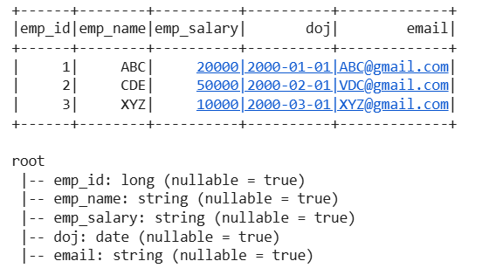

emp_df.describe()
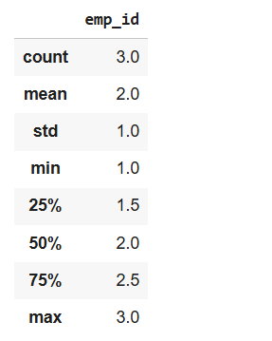

df = spark.createDataFrame([
['red', 'banana', 1, 10], ['blue', 'banana', 2, 20], ['red', 'carrot', 3, 30],
['blue', 'grape', 4, 40], ['red', 'carrot', 5, 50], ['black', 'carrot', 6, 60],
['red', 'banana', 7, 70], ['red', 'grape', 8, 80]], schema=['color', 'fruit', 'v1', 'v2'])
df.show()
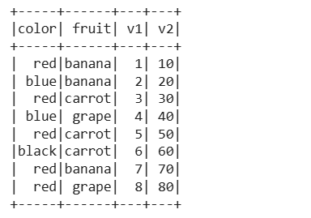

df.groupby('color').avg().show()
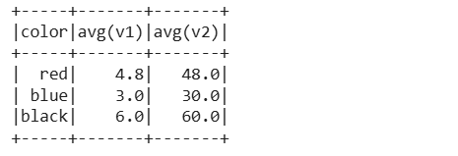

df.groupby('color').avg('v2').show()
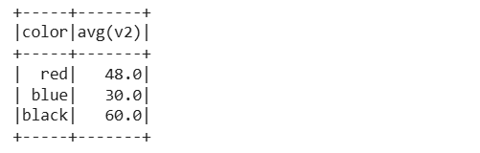

df.filter(df.color == 'red').groupby('color').avg('v2').show()
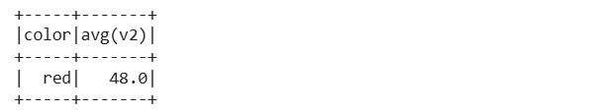

BDA Practical No-7
Temperature data Analysis using Pyspark

Introduction
Temperature data analysis is an important application of big data processing used to study weather patterns and climate conditions. PySpark provides a distributed computing environment that allows large temperature datasets to be processed efficiently.

Objective
The objective of this practical is to analyze temperature data using PySpark in order to perform basic operations such as finding maximum, minimum, and average temperature values.

Concept of PySpark in Data Analysis
PySpark is the Python interface for Apache Spark. It allows large datasets to be processed in parallel using distributed computing. PySpark is suitable for analyzing temperature data collected over long periods and from multiple locations.

Dataset Description
The temperature dataset consists of records containing information such as date, location, and temperature values. Each record represents a temperature reading which can be processed using PySpark.

Working Principle
The temperature data is first loaded into PySpark as a Resilient Distributed Dataset (RDD). The data is then transformed using map operations to extract temperature values. Reduce and aggregate operations are applied to calculate statistical measures such as minimum, maximum, and average temperature.

Data Processing Using RDD
RDD operations such as map, reduce, and filter are used to process the temperature data. These operations enable efficient handling of large datasets by distributing computation across multiple nodes.

Temperature Analysis Operations
PySpark is used to compute the maximum temperature, minimum temperature, and average temperature from the dataset. These operations help in understanding temperature variations and trends.

Advantages of Using PySpark
PySpark offers fast processing, scalability, and fault tolerance. It can handle large volumes of temperature data efficiently and provides flexibility through Python programming.

Applications
Temperature data analysis using PySpark is applied in weather forecasting, climate monitoring, environmental studies, and disaster management systems.

Conclusion
Temperature Data Analysis using PySpark demonstrates how big data tools can be used to process and analyze large environmental datasets efficiently. PySpark provides a powerful platform for performing temperature analysis in a distributed environment.

Code:

from pyspark.sql import SparkSession
spark = SparkSession.builder.appName('MaxTemperature').getOrCreate()
rdd = spark.sparkContext.textFile("/content/Temperature.txt")
print(rdd.collect())
def extract_decade_temp(line):
parts = line.split(" ")
year = int(parts[0])
temp = float(parts[1])
decade = int(year//10) *10
return(decade,temp)
decade_temp_rdd = rdd.map(extract_decade_temp)
max_temp_rdd = decade_temp_rdd.reduceByKey(lambda x,y: max(x,y))

for decade,max_temp in max_temp_rdd.collect():
print(f"{decade} : Highest Temperature = {max_temp} Celcius")
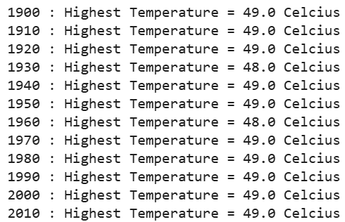

BDA Practical No-8
Data cube creation

Aim: Import the cube form data in Microsoft Excel and create the Pivot table and Pivot Chart to perform data analysis.

Theory:
Explain the nature of cube data, its dimesions with one real time example.
Case 1:
Dataset: ProductData
Steps:
1. Design first pivot table ProductByRegion
Column-> Region
Rows-> Product
Values-> Sum of Quantity sold
Filter-> Year

Output:

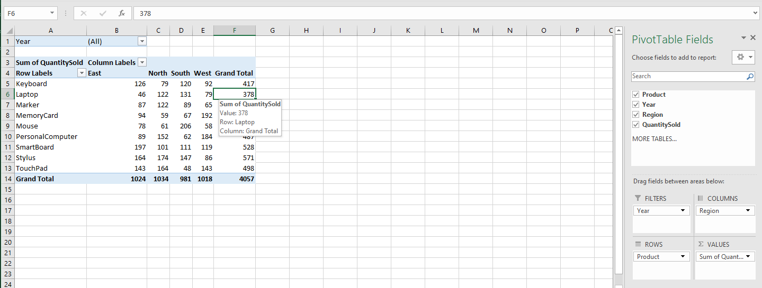

2. In the same sheet create RegionByYear
Column-> Region
Rows-> Year
Values-> Sum of Quantity sold
Output:
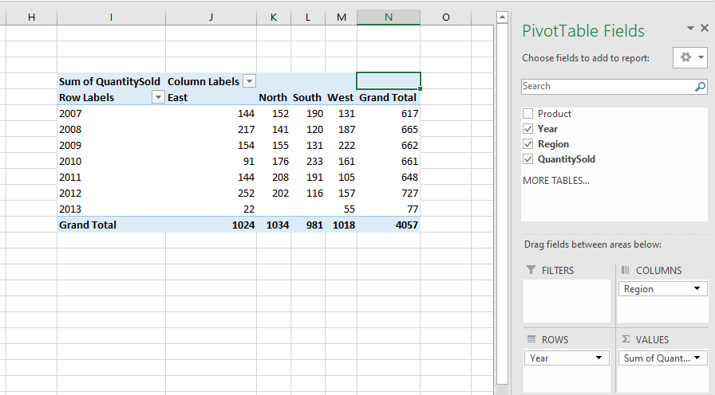

3. In the same sheet create ProductByYear
Rows-> Product
Columns-> Year
Values-> Sum of Quantity sold
Output:
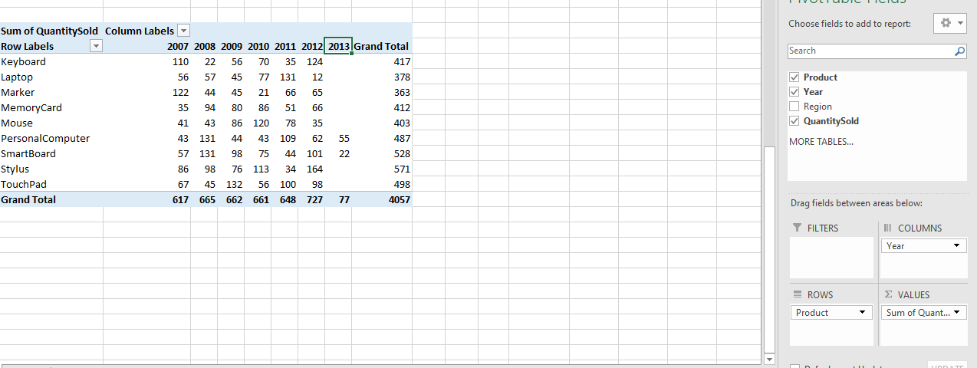

4. Remove Grant total from row and columns of all table
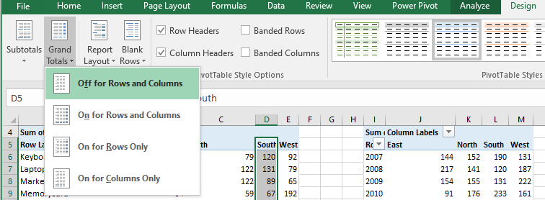
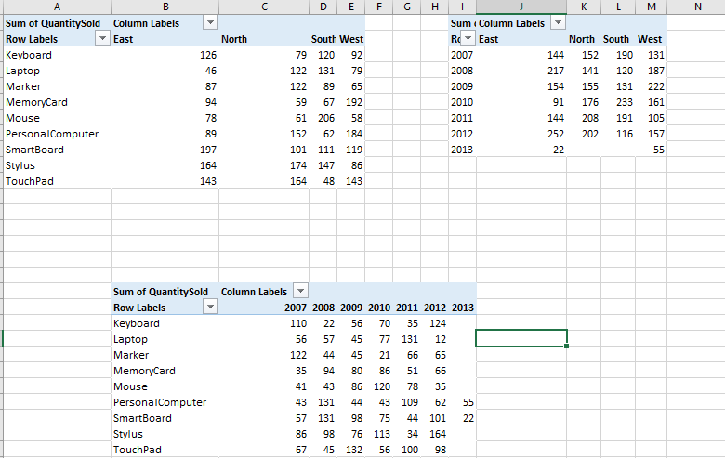

5. Create table out of pivot table by giving proper column names
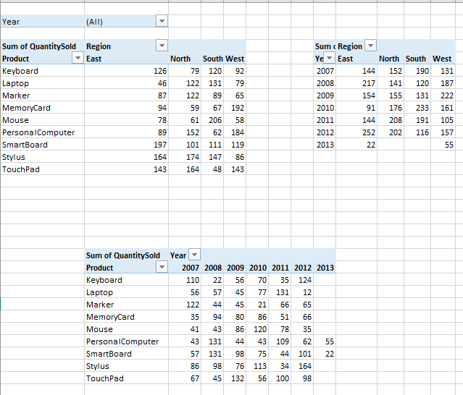
6. Copy values of created tables by using formula
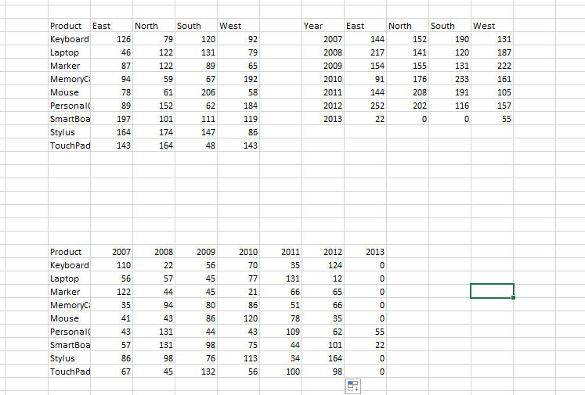

7. Create another sheet and copy new data there using pastelink
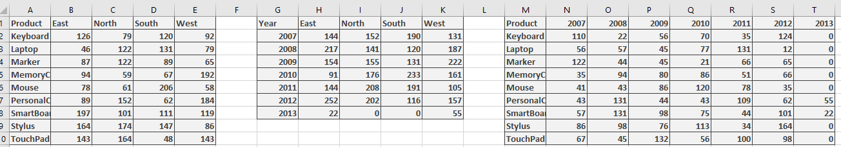

8. Colour column rows, columns with appropriate colours

9. Give 3D effect
Select data not columns, copy it, paste it as picture link and give 3D effect.
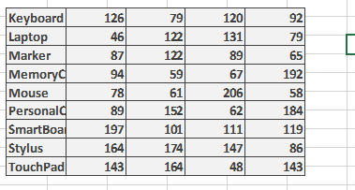

10. Apply filter to year in descending order.
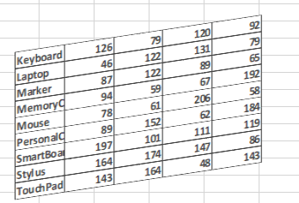

11. Group all three images
Select all 3 images, right click and group
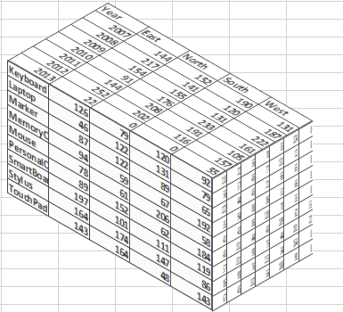
12. Add slicers according to year, product etc
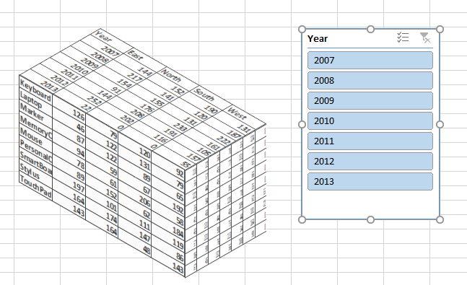

13. Create pivot chart from these pivot tables in cube format only.

Case2:
Dataset:

